

**AMERICAN INTERNATIONAL UNIVERSITY – BANGLADESH**

**OBJECT ORIENTED PROGRAMMING 2**

**Project Proposal**

**FALL 2023-2024**

Supervise By

**TONNY SHEKHA KAR**

**Project Title: Khela Ghor (Collection of mini games)**

**Section: I**

Group members:

|  |  |
| --- | --- |
| **NAME** | **ID** |
| MD. SHOHANUR RAHMAN SHOHAN | 22-46013-1 |
| FARJANA YESMIN OPI | 22-47018-1 |
| MD. ABU TOWSIF | 22-47019-1 |

ER DIAGRAM

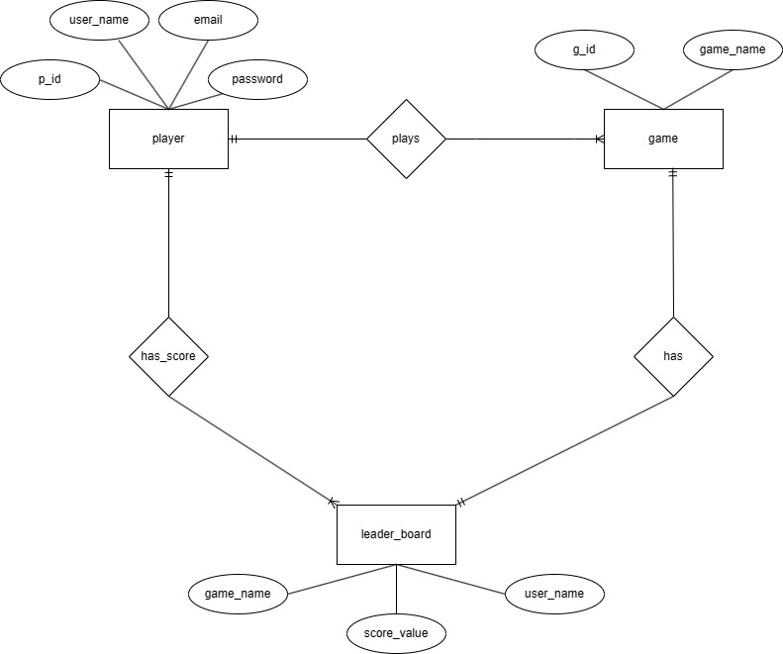

TABLE SCHEMA